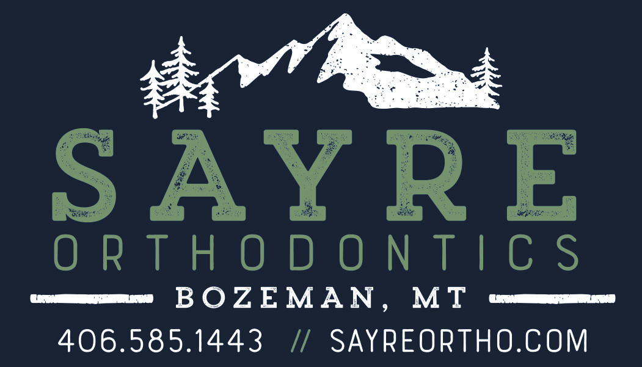

PATIENT INFORMATION

Patient's Last Name |  |  |  | Patient's First Name |  |  |  |  | Patient's Preferred Name (Nickname) |  |  |  |  |  | M / F
Patient's DOB | Patient's Age |  | Patient's Email Address |  |  |  |  |  |  |  | Patient's Social Security #
Patient's Street Address |  |  |  |  |  | Patient's City, State, Zip |  |  |  | Patient's Landline # |  |  | Patient's Cell #
Any other family members treated here?  □ Yes □ No |  | If yes, who?
Other Sibling/Child Full Name |  |  | M / F |  | Sibling/Child DOB |  | Other Sibling/Child Full Name |  |  |  |  | M / F |  | Sibling/Child DOB
Patient's Dentist |  |  |  |  |  |  |  | Date of last dental cleaning
Whom may we thank for referring you to our office? |  |  |  |  |  |  | If patient is a minor, parent or guardian's name
RESPONSIBLE PARTY INFORMATION

Resp. Party's Last Name |  |  | Resp. Party's First Name |  |  |  |  | Resp. Party's Email Address |  |  |  |  |  | Relationship to Patient
Resp. Party's Street Address (if different from patient address) |  |  |  | Resp. Party's City, State, Zip |  |  |  |  | Resp. Party's Landline # |  |  |  | Resp. Party's Cell #
How long at this address? | Marital Status  □ Single □ Married □ Divorced □ Widowed □ Separated |  |  |  |  |  |  |  | Resp. Party's Social Security #
Previous Street Address (if less than 3 years at current address) |  |  |  |  |  |  |  |  |  | Previous City, State, Zip
Resp. Party's Employer |  |  |  |  | Resp. Party's Occupation |  |  |  |  | # Yrs at Employer |  |  |  | Resp. Party's DOB
Resp. Party's Spouse/Partner Name |  |  | Spouse/Partner Relationship to Patient |  |  |  | Spouse/Partner Employer |  |  |  | Spouse/ Partner Occupation |  |  |  | # Yrs at Employer
Spouse/Partner DOB |  | Spouse/Partner Social Security # |  |  |  | Spouse/Partner Cell # |  |  |  |  |  | Spouse/Partner Work #
PRIMARY DENTAL INSURANCE INFORMATION

Subscriber's Last Name | Subscriber's First Name |  | Subscriber's Relationship to Patient |  | Subscriber's DOB
Insurance Company's Name |  | Insurance Company's Phone # |  | Subscriber's Member # |  | Subscriber's Group #
EMERGENCY INFORMATION (RELATIVE/FRIEND NOT LIVING WITH YOU)

Emergency Contact's Name |  | Emergency Contact's Street Address |  | City, State, Zip
Relationship to Patient | Emergency Contact's Landline # |  | Emergency Contact's Cell #
Please continue on back

Has an orthodontist been previously consulted?  □ Yes □ No | Are antibiotics necessary for dental cleanings?  □ Yes □ No |  |  |  | Has patient ever taken bisphosphonates (Aredia, Zometa, Fosamax, Actonel or Boniva)?  □ Yes □ No
List any drugs/things patient is allergic to or has a reaction to: |  |  | List any medications patient is currently taking: |  |  |  | Physician's Name:
What is your dentist's main orthodontic concern? |  |  | Is there any dental work needing to be completed prior to orthodontic treatment? □ Yes □ No  If yes, please explain: |  |  |  | Is patient under the care of a physician at this time?  □ Yes □ No  If yes, please explain:
Indicate patient's feeling toward orthodontic treatment:  □ Excited to get started  □ Complacent  □ Not Committed |  | Indicate patient's reasons for seeking orthodontic treatment:  □ Esthetics  □ Dental Function  □ Overall Health |  |  |  | Please describe any orthodontic concerns and what you would like accomplished:
Personality Assessment (Please check all that describe patient)  □ Nervous □ Outgoing □ Serious  □ Calm □ Uncooperative □ Humorous  □ Confident □ Sensitive □ Cooperative  □ Shy □ Afraid □ Independent |  |  |  | Does patient have clicking, popping or pain in jaw joints? □ Yes □ No  If yes, which sides, since when and during what activity?

CHECK YES OR NO IF PATIENT CURRENTLY HAS OR HAS HAD:

Adenoids/ tonsils abnormal | □ | Yes | □ | No | Heart problems | □ | Yes | □ | No | Has patient reached puberty? | □ Yes | □ | No
Adenoids/ tonsils removed | □ | Yes | □ | No | Hemophiliac | □ | Yes | □ | No | Abnormal height or weight? | □ Yes | □ | No
ADD/ ADHD | □ | Yes | □ | No | Hepatitis | □ | Yes | □ | No | Is the patient adopted? | □ Yes | □ | No
AIDS/ HIV | □ | Yes | □ | No | Herpes | □ | Yes | □ | No | If adopted,does he/she know? | □ Yes | □ | No
Allergy/ sinus trouble | □ | Yes | □ | No | High/ low blood pressure | □ | Yes | □ | No | Is the patient pregnant? | □ Yes | □ | No
Anemia | □ | Yes | □ | No | Jaundice | □ | Yes | □ | No | Food allergies? | □ Yes | □ | No
Arthritis | □ | Yes | □ | No | Kidney disease | □ | Yes | □ | No | Latex allergy? | □ Yes | □ | No
Artificial heart valves | □ | Yes | □ | No | Liver disease | □ | Yes | □ | No | Nickel allergy? | □ Yes | □ | No
Asthma | □ | Yes | □ | No | Muscle/ joint problems | □ | Yes | □ | No
Autism | □ | Yes | □ | No | Organ transplant | □ | Yes | □ | No | Is bite uncomfortable? | □ Yes | □ | No
Bone disorders | □ | Yes | □ | No | Osteoporosis | □ | Yes | □ | No | Any facial injuries? | □ Yes | □ | No
Blood disease | □ | Yes | □ | No | Physical disabilities | □ | Yes | □ | No | Trauma to the jaw? | □ Yes | □ | No
Cancer | □ | Yes | □ | No | Psychiatric problems | □ | Yes | □ | No | Trauma to any teeth? | □ Yes | □ | No
Cardiac pacemaker | □ | Yes | □ | No | Radiation/ chemo / blood therapy | □ | Yes | □ | No | Clenching teeth? | □ Yes | □ | No
Chronic cough | □ | Yes | □ | No | Respiratory problems | □ | Yes | □ | No | Grinding teeth? | □ Yes | □ | No
Diabetes | □ | Yes | □ | No | Rheumatic/ scarlet/ yellow fever | □ | Yes | □ | No | Missing/extra permanent teeth? | □ Yes | □ | No
Down syndrome | □ | Yes | □ | No | Scoliosis | □ | Yes | □ | No | Does the patient smoke? | □ Yes | □ | No
Drug addiction | □ | Yes | □ | No | Shortness of breath | □ | Yes | □ | No | Cheek, tongue or lip chewing? | □ Yes | □ | No
Ear problems | □ | Yes | □ | No | Stroke | □ | Yes | □ | No | Finger/ thumb/ lip sucking? | □ Yes | □ | No
Endocrine problems | □ | Yes | □ | No | Thyroid problems | □ | Yes | □ | No | Fingernail habit? | □ Yes | □ | No
Epilepsy | □ | Yes | □ | No | TMJ problems | □ | Yes | □ | No | Mouth breathing? | □ Yes | □ | No
Faintness/ dizziness | □ | Yes | □ | No | Tuberculosis | □ | Yes | □ | No | Difficulty breathing thru nose? | □ Yes | □ | No
Fever blisters | □ | Yes | □ | No | Venereal disease | □ | Yes | □ | No | Snore while sleeping? | □ Yes | □ | No
Headaches (frequent) | □ | Yes | □ | No | Whiplash | □ | Yes | □ | No | Speech problems? | □ Yes | □ | No
Heart murmur | □ | Yes | □ | No | Wound healing problems | □ | Yes | □ | No | Strong gag reflex? | □ Yes | □ | No
Please explain ANY medical or dental conditions not mentioned above:

PATIENT CONSENT
The undersigned hereby authorizes Dr. Jeremy Sayre and the staff of Sayre Orthodontics to take x-rays, study models, photographs and an orthodontic examination in order to make a thorough diagnosis of the patient's orthodontic needs. It is my responsibility to inform this office immediately of any changes in any medical status. I understand that when appropriate credit bureau reports may be obtained.

Patient or responsible party signature ( if patient is under 18 yrs old ) Date

